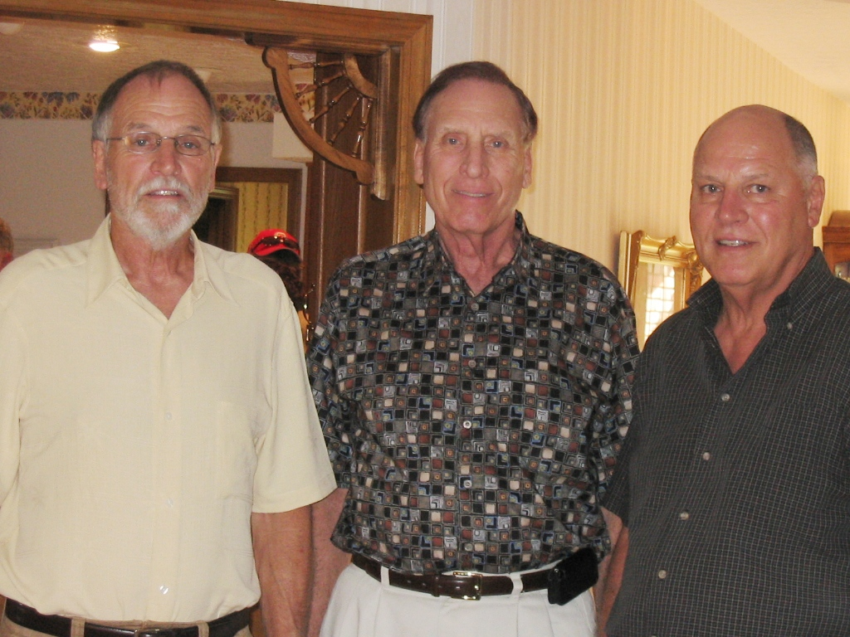

Wolfe brothers: Nelson, Philip and John – 2008

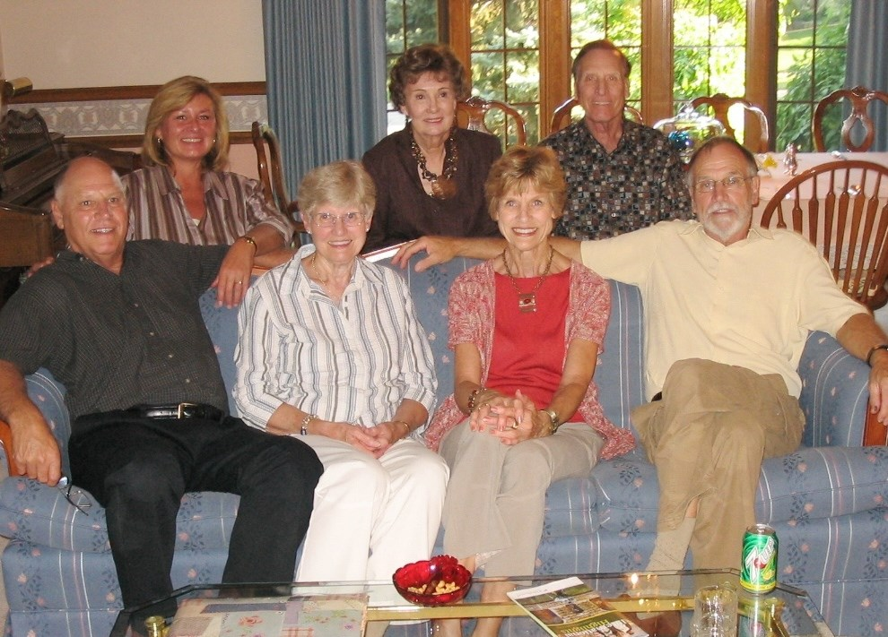

Back row: Tamey, Marg, Phil,

John, Lois, Mary Jo, and Nelson - 2008